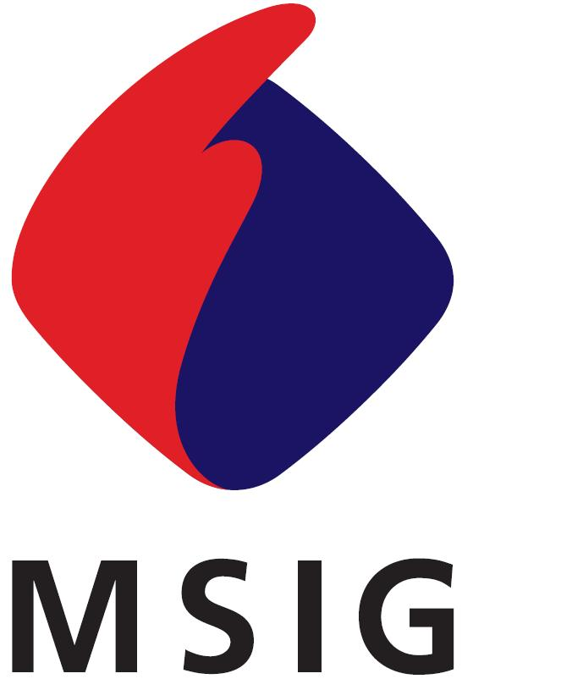
三井住友海上火灾保险（中国）有限公司
Mitsui Sumitomo Insurance (China) Company, Limited
中国上海市浦东新区世纪大道100号 上海环球金融中心 34楼T70室
34-T70, Shanghai World Financial Center, 100 Century Avenue,
Pudong New Area, Shanghai, China
致：三井住友海上火灾保险（中国）有限公司
To: Mitsui Sumitomo Insurance (China) Company, Limited
保险公司签收
财产损失索赔函 ・ 事故报告书
PROPERTY DAMAGE CLAIM AND ACCIDENT REPORT
POLICY NUMBER  保险单号码： |  | INSURANCE CLASS  保险险种：
INSURED  被保险人名称： |  | CLAIM AM'T  索赔金额：
PRESENT ADDRESS
地址：
WHICH OCCURRED ON  事故发生日期： | (Y) /(M) /(D)  _________/______/______  年 月 日 | LOCATION OF THE LOSS  事故地点：
SUMMARY OF THE LOSS  事故概要： | [ ] SEE ATTACHED REPORT  [ ] 附事故损失报告参照 | CAUSED BY  损失原因：
THERE IS NO OTHER INSURANCE APPLICABLE TO THIS LOSS EXCEPT AS STATED HEREUNDER
请说明其他对本事件有效之保险
INSURANCE COMPANY  保险公司名称 | POLICY PERIOD  保险期间 | COVERAGE OR BOND FORM  保险险种 |  | AMOUNT OF INSURANCE  保险金额
PLEASE COMPLETE THIS FORM IN DETAIL AS MUCH AS POSSIBLE, OTHERWISE THE CLAIM WILL BE PREJUDICED.
IT IS UNDERSTOOD AND AGREED THAT THE FURNISHING OF THIS FORM TO THE INSURED OR ITS PREPARATION BY ANY REPRESENTATIVE OF THE COMPANY OR THE ACCEPTANCE OR RETENTION OF THE PROOF THEREAFTER BY THE COMPANY SHALL NOT CONSTITUTE A WAIVER OF ANY OF THE CONDITIONS OF THE POLICY.
请务必完整填写此表格，以保障您的索赔权利。
兹声明：本公司向被保险人或其代表提供此事故报告书及其日后接受或保留其他之有关证明，均不构成公司对保险单上所载之任何条款
予以放弃。

I/WE HEREBY DECLARE INFORMATION GIVEN ABOVE IS MADE TRUE AND CORRECT AND TO THE BEST OF MY/OUR KNOWLEDGE.
我/我们郑重声明：本表格所反映的信息是尽我/我们所知及所信，本表格的资料全属正确无误。
I/WE HEREBY UNDERTAKE TO PROVIDE ANY DOCUMENTS OR ASSISTANCE TO THE INSURER FOR RECOVERY AGAISNT ANY OTHER THIRD LIABLE PARTY ACCORDING TO THE POLICY.
我/我们承诺根据保险合同规定，协助保险公司向任何有责任的第三方进行追偿。
AFTER I/WE’VE RECEIVED THE FINAL AND TOTAL CLAIM AMOUNT, WE WILL NOT CLAIM AGAINST YOUR COMPANY ANY MORE WITH REGARD TO THIS ACCIDENT.
我/我们收到上述最终及全部赔款后，就此事故不再向贵司提出任何索赔。
I/WE PROMISE THAT CONCERING THE LOSS/DAMAGE OF THIS INSURANCE CLAIM APPLICATION, HAVE NEVER RECEIVED ANY COMPENSATION FROM ANY THIRD PARTY. IF THERE IS ANY DISCREPANCY, I/WE PROMISE TO RETURN THE INSURANCE INDEMNITIES BACK TO YOUR COMPANY PROMPTLY.
我/我们承诺就本次向贵司申请理赔的损失未从任何第三方获得赔偿，如有与上述不符的情况，我/我们承诺返还相应的保险赔偿金。

ON THE DATE OF  日期： ＿＿＿＿＿＿(Y:年)＿＿＿(M:月)＿＿＿(D:日)  AT THE LOCTION OF  地址： |  | ＿＿＿＿＿＿＿＿＿＿＿＿＿＿＿＿＿＿＿＿＿＿＿＿  SIGNATURE OF THE INSURED  被保险人署名/盖章
[ ] PLEASE PAY BY CHECK [ ] 请用支票支付
[ ] PLEASE PAY BY WIRE-TRANSFER [ ] 请通过银行转帐
NAME OF BANK  银行名 | NAME OF BRANCH  分支行名 | ACCOUNT NUMBER  帐号 |  | ACCOUNT NAME  帐号名称
PROPERTY DAMAGE BACK PAGE
FOR BURGLARY LOSSES ONLY
如系暴力盗窃案件，请填写以下内容
WERE THERE VISIBLE MARKS OF FORCIBLE ENTRY TO THE PREMISES?  现场是否有暴力侵入或毁坏的痕迹 |  |  | YES / NO  有 / 无
IF ANSWER IS "YES", DESCRIBE THESE MARKS IN DETAIL
如有、请详细说明
TO ANY SAFE OR VAULT INSURED?  是否有保险箱或金库保险 |  | YES / NO  有 / 无 | Insurance Company保险公司
FOR THEFT OR ROBBERY
如系盗窃或抢劫，请填写以下内容
NAMES AND ADDRESS OF CUSTODIANS, GUARDS AND WITNESSES
请说明有关财物之管理人、看护人或目击证人的姓名及地址
NAME  姓名 | ADDRESS  地址 | CUSTODIAN, GUARD OR WITNESS  管理人、看护人或目击证人
POLICE REPORT
警署的有关记录
WHERE MADE  所属之地区 |  | DATE FILED  报案日期
POLICE CASE REFERENCE NUMBER
警署之挡案编号

STATEMENT OF CLAIM FOR LOSS/DAMAGE
索赔申请明细书
DESCRIPTION OF LOST/DAMAGED PROPERTIES  受损物件之详细说明 | NAME AND ADDRESS OF OWNER  姓名及地址 | ACQUIRED FROM  (NAME AND ADDRESS)  购买店名称和地址 | DATE ACQUIRED  购买日期 | ORIGINAL COST OR PRICE  原价 | AMOUNT CLAIMED  索赔金额

