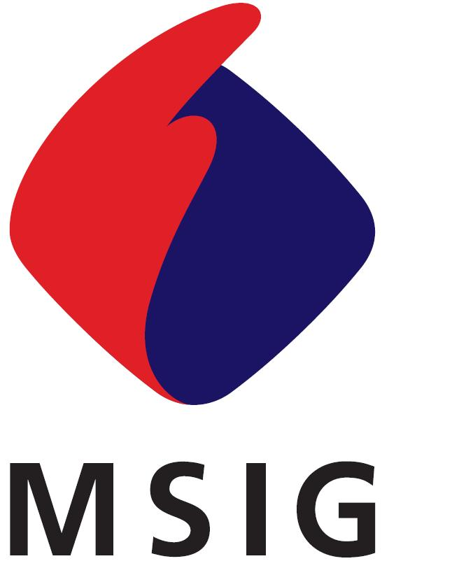
三井住友海上火災保険（中国）有限公司
Mitsui Sumitomo Insurance (China) Company, Limited.
中国上海市浦东新区世纪大道100号 上海环球金融中心 34楼T70室
34-T70,Shanghai World Financial Center,100 Century Avenue, Pudong New Area, Shanghai, China

致：三井住友海上火災保険（中国）有限公司
To: Mitsui Sumitomo Insurance (China) Company, Limited.
保险公司签收

货运险损失索赔函
MARINE CLAIM NOTE
INSURED
被保险人名称：
PRESENT ADDRESS
地址：
CLAIMANT
索赔人名称：
PRESENT ADDRESS
地址：
CLAIM NUMBER  赔案号： |  |  | POLICY NUMBER  保单号：
INTERESTS  保险标的： |  |  | INVOICE NUMBER  发票号/运单号：
ACCIDENT DATE  事故日期： |  |  | NATURE OF LOSS  事故类型：
CONVEYANCE  运输工具： |  |  | DOUBLE INSURNACE  重复保险： |  | □YES 是 ■NO无
CLAIM AMOUNT’S CALCULATION
索赔金额计算：

索赔金额：
THE ABOVE CLAIM AMOUNT IS以上金额为此次损失的：
■FINAL AND TOTAL CLAIM AMOUNT最终及全部索赔金额 □PARTIAL CLAIM AMOUNT部分索赔金额
PLEASE REMIT THE ABOVE AMOUNT TO THE FOLLOWING BANK ACCOUNT/请将上述赔款付到以下银行账户
（OR STAMP THE FINANCIAL DEPT.’S BANK CHOP/或盖财务银行章）
NAME OF BANK  银行名 |  | NAME OF BRANCH  分支行名 |  | ACCOUNT NUMBER  账号 |  | ACCOUNT NAME  账号名称
DECLARATION声明
I/WE HEREBY DECLARE THAT THE INFORMATION GIVEN ABOVE IS TRUE AND CORRECT AND TO THE BEST OF MY/OUR KNOWLEDGE.我/我们郑重声明：本表格所反映的信息是尽我/我们所知及所信，本表格的资料全属正确无误。并无任何保留。
THIS GIVEN FORM WILL NOT INFLUENCE THE INSURANCE CONTRACT BETWEEN THE INSURER AND ME/US.此表并不改变或影响保险合同的各项规定。
I/WE HEREBY UNDERTAKE TO PROVIDE ANY DOCUMENTS OR ASSISTANCE TO THE INSURER FOR RECOVERY AGAISNT ANY OTHER THIRD LIABLE PARTY ACCORDING TO THE POLICY.我/我们承诺根据保险合同规定，协助保险公司向任何有责任的第三方进行追偿。
AFTER I/WE’VE RECEIVED THE FINAL AND TOTAL CLAIM AMOUNT, WE WILL NOT CLAIM AGAINST YOUR COMPANY ANY MORE WITH REGARD TO THIS ACCIDENT.我/我们收到上述最终及全部赔款后，就此事故不再向贵司提出任何索赔。
I/WE PROMISE THAT CONCERING THE LOSS/DAMAGE OF THIS INSURANCE CLAIM APPLICATION, HAVE NEVER RECEIVED ANY COMPENSATION FROM ANY THIRD PARTY. IF THERE IS ANY DISCREPANCY, I/WE PROMISE TO RETURN THE INSURANCE INDEMNITIES BACK TO YOUR COMPANY PROMPTLY. 我/我们承诺就本次向贵司申请理赔的损失未从任何第三方获得赔偿，如有与上述不符的情况，我/我们承诺返还相应的保险赔偿金。

＿＿＿＿＿＿＿＿＿＿＿＿＿＿＿＿＿＿＿＿＿＿
SIGNATURE OF THE INSURED
被保险人/索赔人署名/盖章
DATE
填表日期： (Y:年) (M:月) (D:日)

