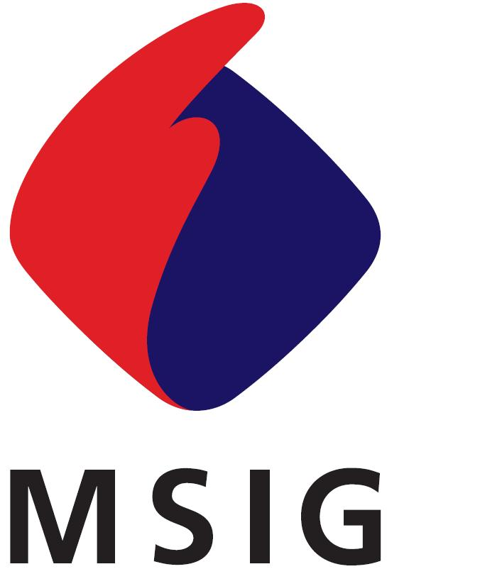
三井住友海上火灾保险（中国）有限公司
Mitsui Sumitomo Insurance (China) Company, Limited
中国上海市浦东新区世纪大道100号 上海环球金融中心 34楼T70室
34-T70, Shanghai World Financial Center, 100 Century Avenue,
Pudong New Area, Shanghai, China
致：三井住友海上火灾保险（中国）有限公司
保险公司签收
To: Mitsui Sumitomo Insurance (China) Company, Limited

雇主责任保险索赔函 兼 事故报告书
EMPLOYERS LIABILITY CLAIM AND ACCIDENT REPORT
POLICY NUMBER  保单号码： |  | INSURANCE CLASS  保险险种： | EMPLOYERS LIABILITY  雇主责任险
INSURED  被保险人名称： |  | CLAIM AM'T  索赔金额：
PRESENT ADDRESS
地址：
WHICH OCCURRED AT  事故发生日期： | _______(Y) ____(M)____ (D)  年 月 日  (TIME) : ' | LOCATION OF THE LOSS  事故地点：
SUMMARY OF THE LOSS  事故概要： | [ ] SEE ATTACHED REPORT  [ ] 附事故損失报告参照 | CAUSED BY  损失原因：
THERE IS NO OTHER INSURANCE APPLICABLE TO THIS LOSS EXCEPT AS STATED HEREUNDER
请说明其他对本事件有效之保险
INSURANCE COMPANY  保险公司名称 | POLICY PERIOD  保险期间 | COVERAGE OR BOND FORM  保险险种 |  | AMOUNT OF INSURANCE  投保金额
PLEASE COMPLETE THIS FORM IN DETAIL AS MUCH AS POSSIBLE, OTHERWISE THE CLAIM WILL BE PREJUDICED.
IT IS UNDERSTOOD AND AGREED THAT THE FURNISHING OF THIS FORM TO THE INSURED OR ITS PREPARATION BY ANY REPRESENTATIVE OF THE COMPANY OR THE ACCEPTANCE OR RETENTION OF THE PROOF THEREAFTER BY THE COMPANY SHALL NOT CONSTITUTE A WAIVER OF ANY OF THE CONDITIONS OF THE POLICY.
请务必完整填写此表格，以保障您的索赔权利。
兹声明：本公司向被保险人或其代表提供此事故报告书及其日后接受或保留其他之有关证明，均不构成公司对保险单上所载之任何条款
予以放弃。

I/WE HEREBY DECLARE INFORMATION GIVEN ABOVE IS MADE TRUE AND CORRECT AND TO THE BEST OF MY/OUR KNOWLEDGE.
我/我们郑重声明：本表格所反映的信息是尽我/我们所知及所信，本表格的资料全属正确无误。
I/WE HEREBY UNDERTAKE TO PROVIDE ANY DOCUMENTS OR ASSISTANCE TO THE INSURER FOR RECOVERY AGAISNT ANY OTHER THIRD LIABLE PARTY ACCORDING TO THE POLICY.
我/我们承诺根据保险合同规定，协助保险公司向任何有责任的第三方进行追偿。
AFTER I/WE’VE RECEIVED THE FINAL AND TOTAL CLAIM AMOUNT, WE WILL NOT CLAIM AGAINST YOUR COMPANY ANY MORE WITH REGARD TO THIS ACCIDENT.
我/我们收到上述最终及全部赔款后，就此事故不再向贵司提出任何索赔。
I/WE PROMISE THAT CONCERING THE LOSS/DAMAGE OF THIS INSURANCE CLAIM APPLICATION, HAVE NEVER RECEIVED ANY COMPENSATION FROM ANY THIRD PARTY. IF THERE IS ANY DISCREPANCY, I/WE PROMISE TO RETURN THE INSURANCE INDEMNITIES BACK TO YOUR COMPANY PROMPTLY.
我/我们承诺就本次向贵司申请理赔的损失未从任何第三方获得赔偿，如有与上述不符的情况，我/我们承诺返还相应的保险赔偿金。

ON THE DATE OF  日期： ＿＿＿＿＿＿(Y:年)＿＿＿(M:月)＿＿＿(D:日)  AT THE LOCTION OF  地址： |  | ＿＿＿＿＿＿＿＿＿＿＿＿＿＿＿＿＿＿＿＿＿＿＿＿  SIGNATURE OF THE INSURED  被保险人署名/盖章
[ ] PLEASE PAY BY CHECK [ ] 请用支票支付
[ ] PLEASE PAY BY WIRE-TRANSFER [ ] 请通过银行转帐
NAME OF BANK  银行名 | NAME OF BRANCH  分支行名 | ACCOUNT NUMBER  帐号 |  | ACCOUNT NAME  帐号名称

EMPLOYERS LIABILITY CLAIM BACK PAGE
DETAILS OF ACCIDENT
事故详细情况
NAME, SEX AND AGE OF  INJURED EMPLOYEE  受伤雇员姓名及性別 | NAME/姓名 |  | SEX/性别 | AGE/年龄
IDENTITY CARD NUMBER  受伤雇员身份证号 |  | YEARS OF EMPLOYMENT  受伤雇员受雇年数
DESCRIBE HIS/HER OCCUPATIONAL DUTY IN DETAIL  请详细说明该雇员的工作职责 |  | INJURY RESULTED IN DEATH? IF SO, WHEN DIED?  工伤是否导致死亡？如是，说明死亡的时间
EMPLOEE'S ADDRESS AND TELEPHONE NUBER
受伤雇员的地址和电话号码

EMPLOYEE'S BODILY INJURIES
雇员所受伤害的详细情况

HOSPITAL NAME
医院名称
HOSPITAL ADDRESS AND TELEPHONE NUMBER
医院地址 电话号码

WAS OR IS THE EMPLOYEE HOSPITALIZED?  该雇员是否住院 |  |  |  | WHEN WAS OR WILL HE/SHE BE DISCHARGED FROM HOSPITAL?  何时出院
WHAT IS THE ESTIMATED PERIOD OF DISABLEMENT?  估计的丧失机能的时间 |  |  |  | WHEN DID THE INJURED WORKER RETURNE TO WORK?  何时重返工作
IF THE INJURY WAS CAUSED BY ANY MACHINERY, PLEASE STATE:
若意外由机器而引起，请说明
TYPE OF MACHINERY  机器类别 | PART CAUSING INJURY  引起事故的部件 |  | WAS THE MACHINERY POWER-DRIVEN?  是否以电力驱动 |  | WAS THE MACHINERY IN MOTION?  机器是否在工作中

IF THE INJURED OR DECEASED EMPLOYEE IN YOUR DIRECT EMPLOYMENT? IF NOT, PLEASE STATE THE NAME, ADDRESS AND TELEPHONE NUMBER OF THE CONTRACTOR WHO EMPLOYED THE INJURED
受伤或死亡的雇员是否是您直接雇佣的，如不是，请说明包工人的姓名、地址和电话号码
NAME OF CONTRACTOR  包工人的姓名 |  | ADDRESS AND TELEPHONE NUMBER OF THE CONTRACTOR  包工人的地址
WAS THE INJURED OR DECEASED EMPLOYEE UNDER THE INFLUENCE OF DRINK OR DRUGS?  雇员在出事故时是否受到药物或酒精的影响 |  | WAS HE IN VIOLATION OF ORDERS OR RULES? IF SO, GIVE THE DETAILS  雇员是否违反了操作规程？如是，请详细说明
IF IT IS THE CASE, STATE WHO WAS NEGLIGENT AND ATTRIBUTABLE TO THE ACCIDENT  如是此情况，请说明是谁的疏忽与责任 |  | STATE THE NAME OF ANY PERSON WHO EYE-WITNESSED THE ACCIDENT  请列举事故的目击证人

* PLEASE COMPLETE AND ATTACH TO THIS FORM "EMPLOYERS LIABILITY LOSS WORK SHEET"
请完成附属的「雇主责任损失清单」

雇主责任损失清单
EMPLOYERS LIABILITY LOSS WORK SHEET

POLICY NUMBER DATE OF ACCIDENT
保单号码： ＿＿＿＿＿＿＿＿＿＿＿＿ 事故日期： ＿＿＿＿＿＿＿＿＿＿＿＿＿
INSURED INJURED EMPLOYEE
被保险人姓名： ________________________ 受伤雇员姓名： ＿＿＿＿＿＿＿＿＿＿＿＿＿

请提供事故发生日前12个月的工资明细：
MONTH  月份 | CASH WAGES  INCLUDING OVERTIME WAGES  现金工资包括加班工资 | ALLOWANCE OR BONUS OF CONSTANT NATURE  经常性的津贴与奖金
1

2

3

4

5

6

7

8

9

10

11

12

TOTAL
合计

AVERAGE WAGES INCLUDING OVERTIME WAGES  平均工资包括加班工资 | RMB \ ________________ /MONTH  每月 ____________________ 元
AVERAGE ADDITIONAL ALLOWANCE OR BONUS OF CONSTANT NATRURE  经常性之平均津贴与奖金 | RMB \ ________________ /MONTH  每月 ____________________ 元
TOTAL  总额 | RMB \ ________________ /MONTH  每月 ____________________ 元

DATE SIGNATURE OF
INSURED
日期： ＿＿＿＿＿＿＿＿＿＿＿＿＿＿＿ 被保险人署名/盖章：_________________________________

